

TASK LIST CREATION
Document Control

Prepared by:
Version | Date | Name
1.0 | 01/28/2025 | ARPITA CHANDRAKANT ZOPE
2.0

Reviewed by:
Version | Date | Name
1.0

Reference Documents

The following section describes relevant documentation:
Document Name | Description | Sharepoint Link
TASK LIST CREATION | CREATING A TASK LIST

Contents

1.MAINTENANCE STRATEGY 4
1.1 STEPS 4
2.STEPS TO CREATE A TASK LIST IN SAP PM: 6

1.MAINTENANCE STRATEGY
A Maintenance Strategy in SAP Plant Maintenance (PM) is a framework used to define planned maintenance intervals and their associated tasks for a piece of equipment or a functional location. It helps standardize and organize preventive maintenance activities based on time (calendar-based) or usage (performance-based).

1.1 STEPS

- Use T-code: IP11 (Create Maintenance Strategy).
- Choose new Entries and make following entries (Name, Description, Scheduling Indicator, Strategy unit), then click on save button.
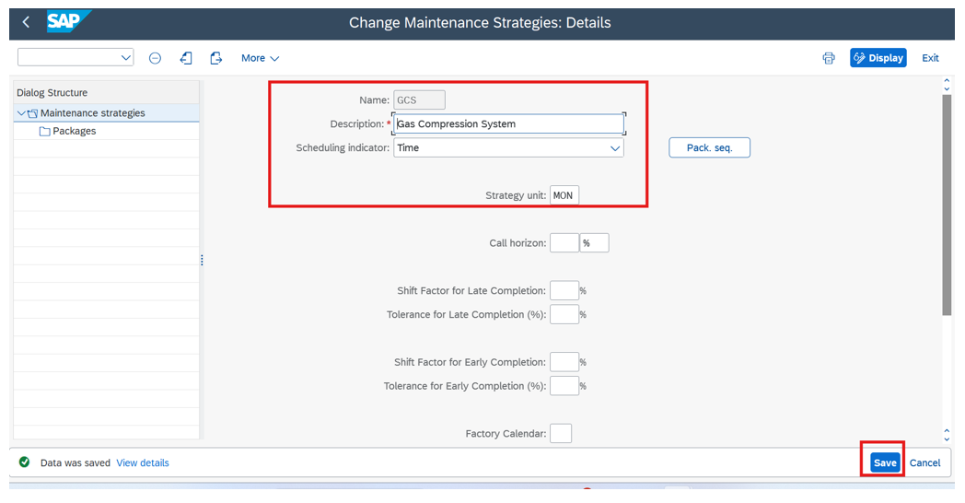

- On the left side of the screen, in the Dialog Structure, double-click on the Packages folder.
Choose New Entries.

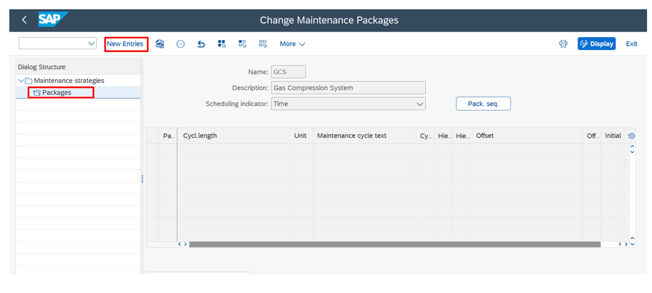

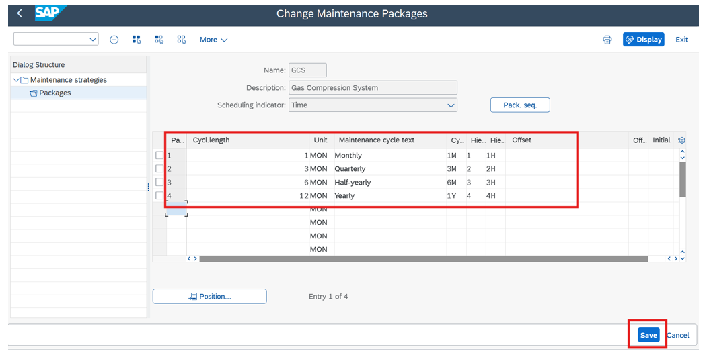
- Make the entries

2.STEPS TO CREATE A TASK LIST IN SAP PM:

      - Access the Task List Transaction Code
- Go to the SAP Easy Access menu.
- Enter the transaction code for the desired type of task list:
    - IA05: Create General Task List
    - IA11: Create Equipment Task List
    - IA15: Create Functional Location Task List
      - Create task list initial screen will appear. Task List Group uses internal number range.
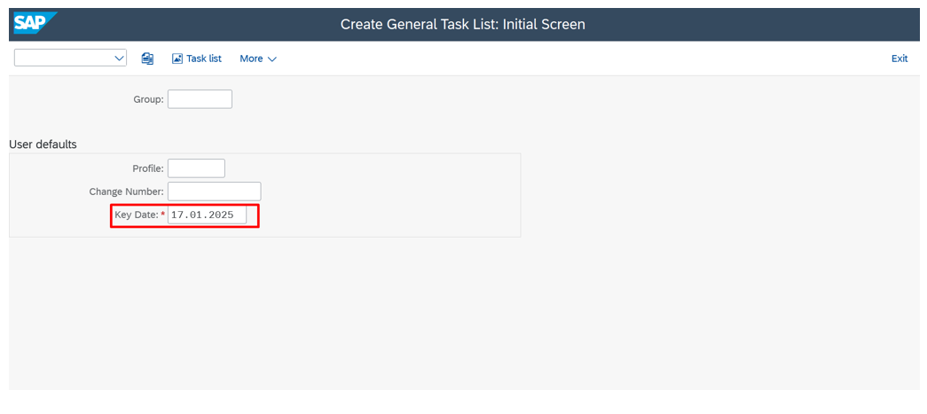

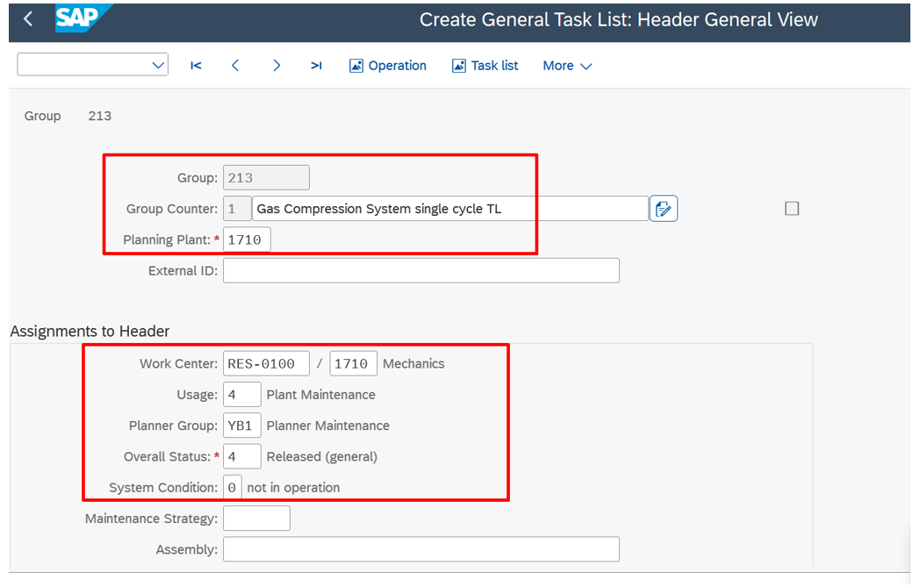
- I) Make the following entries such as description, planning plant, work centre, usage, planner group, overall status, system condition.

II) If strategy is required, enter the strategy in maintenance
strategy field then go to operations tab.

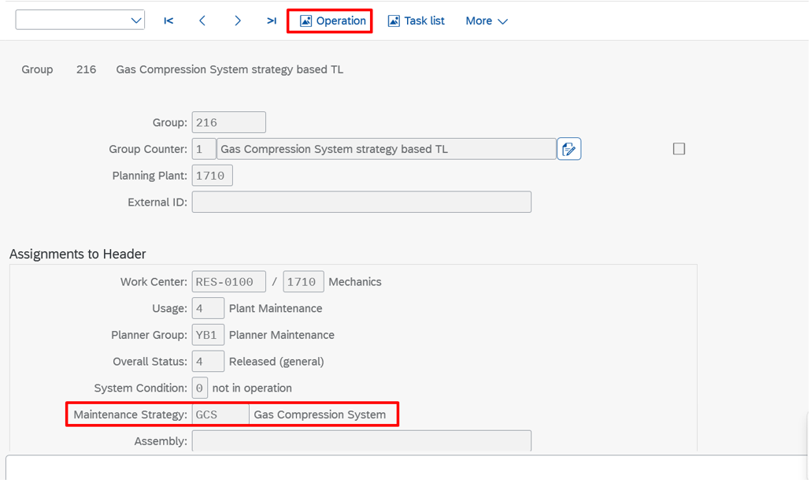
4. I) In operations Tab. Enter the operation description,
work, unit, duration. Then click on save.
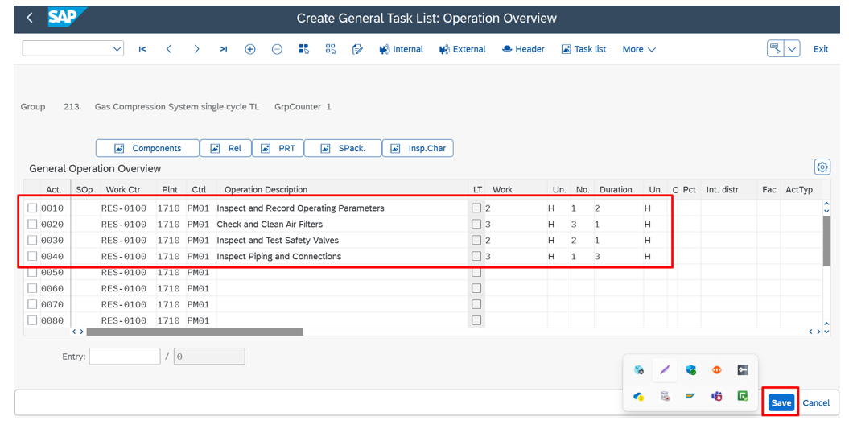

II) For strategy-based task list, after entering operation maintenance package. In maintenance Package, set the as required. E.g. For operation 0010,0020 set flag for monthly, for operation 0030,0040 set flag for quarterly, for operations 0050,0060 set flag for half yearly and for operation 0070,0080 set flag for Yearly. Then click on save.
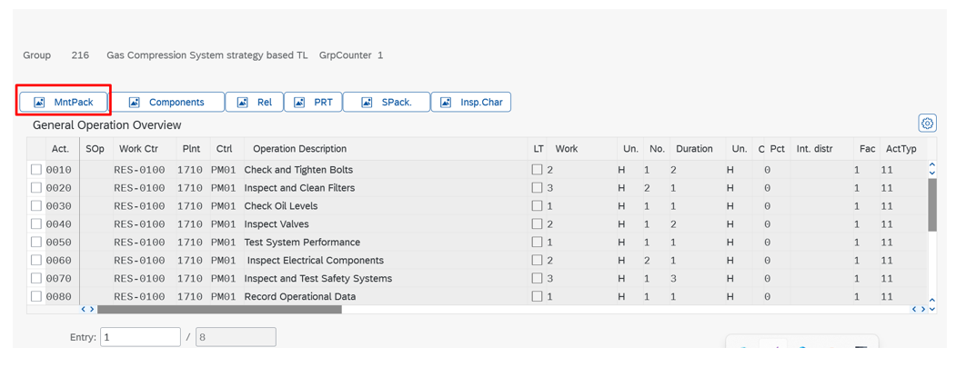
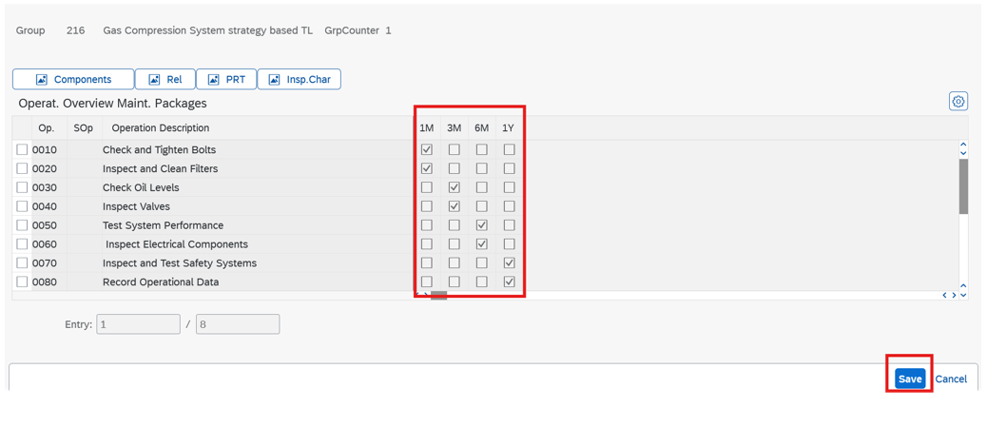

5. Task list created message will appear.

